Table 1. Arabic printed and handwritten digits
Latin Equivalent | 0 | 1 | 2 | 3 | 4 | 5 | 6 | 7 | 8 | 9
Printed |  |  | 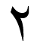 |  |  |  | 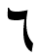 |  |  | 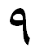
Typical Handwritten |  |  |  |  |  |  |  |  |  | 
Other Writing Style | -- | -- | -- |  | -- | -- | -- | -- | -- | --

